HL Paper 3: Aspects of the history of the Americas
This option covers major developments in the region from around 1760 to 2000: independence movements; the challenges of nation-building; the emergence of the Americas in global affairs; the Great Depression; the Second World War and the Cold War, and their impact on the region, as well as the transition into the 21st century. Within each section political, economic and social issues are considered and, when relevant, cultural aspects are included. The countries of the Americas form a region of great diversity but close historical links.
Within the sections there will be, where appropriate, a case study approach in which students will have the opportunity to study their own or another national history of the region.
Only people and events named in the guide will be named in the examination questions.
In some bullets, suitable examples are shown in brackets. These examples will not be named in the examination questions as any appropriate examples can be used.
Three sections must be selected for in-depth study.
Please note that this option is available only to students who have studied the route 2 SL/HL core syllabus.
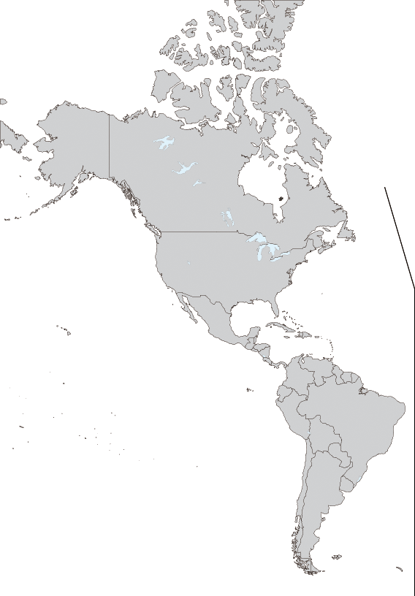
Map of Americas region (borders as of 2000)

3. United States Civil War: causes, course and effects 1840 - 77
This section focuses on the United States Civil War between the North and the South (1861-5), which is often perceived as the great watershed in the history of the United States. It transformed the country forever: Lincoln fostered slavery’s incremental demise with the Emancipation Proclamation and the Northern success marked a victory for the proponents of strong central power over the supporters of states’ rights. It marked the beginnings of further westward expansion and transformed United States’society by accelerating industrialization and modernization in the North and largely destroying the plantation system in the South. The war left the country with a new set of problems: how would the South rebuild its society and economy and what would be the place in that society of 4 million freed African Americans? These changes were fundamental, leading some historians to see the war (and its results) as a “second American Revolution”.
- Cotton economy and slavery; conditions of enslavement; adaptation and resistance such as the Underground Railroad
- Origins of the Civil War: political issues, states’ rights, modernization, sectionalism, the nullification crisis, economic differences between North and South
- Abolitionist debate: ideologies and arguments for and against slavery and their impact
- Reasons for, and effects of, westward expansion and the sectional debates; the crisis of the 1850s; the Kansas–Nebraska problem; the Ostend Manifesto; the Lincoln–Douglas debates; the impact of the election of Abraham Lincoln and the Emancipation Proclamation; Jefferson Davis and the Confederacy
- Union versus Confederate: strengths and weaknesses; economic resources; significance of leaders during the US Civil War (suitable examples could be Grant and Lee, Sherman and Thomas Jonathan “Stonewall” Jackson)
- Major battles of the Civil War and their impact on the conflict: Antietam and Gettysburg; the role of foreign powers
- Reconstruction: economic, social and political successes and failures; economic expansion
- African Americans in the Civil War and in the New South: legal issues; the Black Codes; Jim Crow Laws

5. Emergence of the Americas in global affairs 1880 - 1929
This section focuses on modernization in the region, and its impact on foreign policy. It explores the involvement of the nations in the First World War. Modernization shaped the new nations and its effects created the basis for a major shift in the foreign policies of the region. By the end of the century, for example, the United States played a more active role in world affairs, and in the affairs of Latin America in particular, thus transforming inter-American relations. When the First World War broke out in Europe, several American countries were involved in the conflict. When the war ended, its impact was felt in the economic, social and foreign policies of the participating countries.
- United States’ expansionist foreign policies: political, economic, social and ideological reasons
- Spanish–American War: causes and effects (1898)
- United States’ foreign policies: the Big Stick; Dollar Diplomacy; Moral Diplomacy; applications and impact on the region
- United States and the First World War: from neutrality to involvement; reasons for US entry into the First World War; Wilson’s peace ideals and the struggle for ratification of the Versailles Treaty in the United States; significance of the war for the United States’ hemispheric status
- Involvement and participation of either Canada or one Latin American country in the First World War: reasons for and/or against participation; nature of participation
- Impact of the First World War on two countries of the Americas: economic, political, social, and foreign policies

8. The Second World War and the Americas 1933 - 45
As the world order deteriorated in the late 1930s, resulting in the outbreak of war in Europe, the countries of the region reacted in different ways to the challenges presented. This section focuses on the changing policies of the countries in the region as a result of growing political and diplomatic tensions preceding and during the Second World War. It also examines the impact of the war upon the Americas.
- Hemispheric reactions to the events in Europe: inter-American diplomacy; cooperation and neutrality; Franklin D Roosevelt’s Good Neighbour policy, its application and effects
- The diplomatic and/or military role of two countries in the Second World War
- Social impact of the Second World War on: African Americans, Native Americans, women and minorities; conscription
- Treatment of Japanese Americans and Japanese Canadians
- Reaction to the Holocaust in the Americas
- Impact of technological developments and the beginning of the atomic age
- Economic and diplomatic effects of the Second World War in one country of the Americas

10. The Cold War and the Americas 1945 - 1981
This section focuses on the development and impact of the Cold War on the region. Most of the second half of the 20th century was dominated by the global conflict of the Cold War. Within the Americas, some countries were closely allied to the United States and some took sides reluctantly. Many remained neutral or sought to avoid involvement in Cold War struggles. A few, influenced by the Cuban Revolution, instituted socialist governments. No nation, however, escaped the pressures of the Cold War, which had a significant impact on the domestic and foreign policies of the countries of the region.
- Truman: containment and its implications for the Americas; the rise of McCarthyism and its effects on domestic and foreign policies of the United States; the Cold War and its impact on society and culture
- Korean War and the United States and the Americas: reasons for participation; military developments; diplomatic and political outcomes
- Eisenhower and Dulles: New Look and its application; characteristics and reasons for the policy; repercussions for the region
- United States’ involvement in Vietnam: the reasons for, and nature of, the involvement at different stages; domestic effects and the end of the war
- United States’ foreign policies from Kennedy to Carter: the characteristics of, and reasons for, policies; implications for the region: Kennedy’s Alliance for Progress; Nixon’s covert operations and Chile; Carter’s quest for human rights and the Panama Canal Treaty
- Cold War in either Canada or one Latin American country: reasons for foreign and domestic policies and their implementation

